Sightly 6.3 features

1. **Fetch the properties of a resource**

To fetch some properties of a resource, we need to go for a Java class (either Sling Model or WCMPojo) .But now what we can do:



1. **Request Attributes:** In the data-sly-include and data-sly-resource you can now pass requestAttributes in order to use them in the receiving HTL-script.
2. **Date Formatting**: Before AEM 6.3, if there is a need to format any date in HTL, you need to use a java class to do that. But now this work has also become very easier to us as HTL provides a support of date-format, time zone and locale.

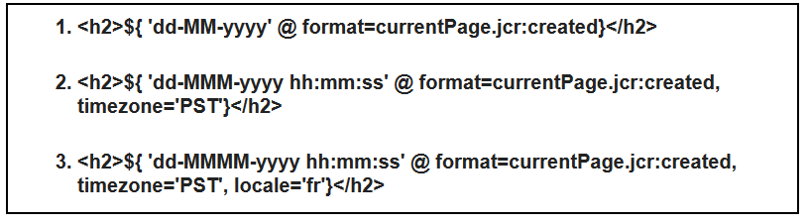

Output:

27-11-2019

27-Nov-2019 04:58:04

27-novembre-2019 04:58:04 (as we can see here, the month text is different as the locale mentioned here is ‘fr’)

1. **Number formatting:** In HTL, now we can show the number in decimal format:

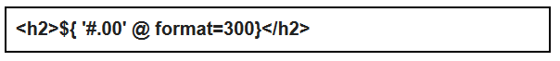

Output: 300.00